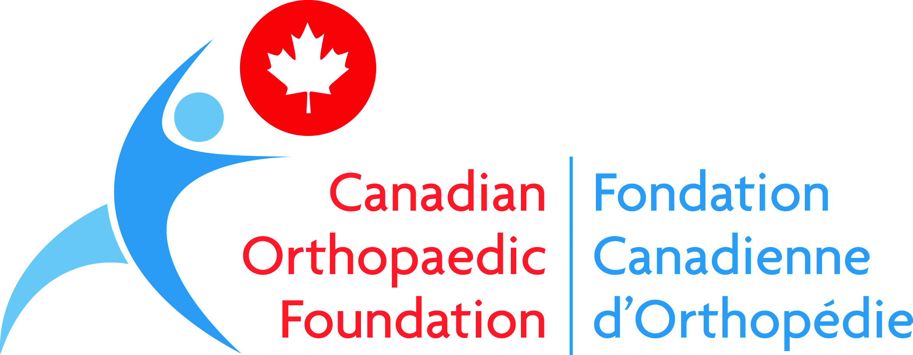

Bones and Phones Legacy Scholarship Fund

Guidelines & Application Form

Applications should be submitted electronically to the
Canadian Orthopaedic Foundation at scholarship@canorth.org
The subject line should state: Scholarship Application – Your Last Name

DEADLINE FOR SUBMISSION

March 31, 2023

1. A DECISION WILL BE COMMUNICATED BY MAY 31, 2023.

2. EMAIL ACKNOWLEDGEMENT OF THE RECEIPT OF AN APPLICATION WILL BE GIVEN WITHIN 1 WEEK OF THE SUBMISSION DEADLINE. IF YOU HAVE NOT RECEIVED NOTIFICATION BY THIS TIME, PLEASE CALL THE FOUNDATION at 416-410-2341 or 1-800-461-3639 Ext.221 and leave a message.

Please read the Application Guidelines in their entirety before completing the application.
Application Guidelines

INTRODUCTION

The Bones and Phones Legacy Scholarship Fund was established to recognize orthopaedic residents who have demonstrated commitment and contribution to enhancing musculoskeletal health in their community, or abroad, beyond that which would be expected during their residency training period. Commitment and contributions may be in the form of volunteerism, education or special events, and must be in addition to what is typically expected during training.

One thousand dollars will be awarded on an annual basis to an orthopaedic resident in his or her second to last year of clinical training and who meet meets the criteria specified below.

Founded by Dr. Veronica Wadey and Mr. Henry Chow, this award recognizes and honors the vital role surgeons play in the lives of others. The scholarship fund celebrates exceptional residents by honoring their dedication to community spirit and/or giving back for the benefit of others. It recognizes individuals that demonstrate passion for orthopaedics and embrace initiatives that go well beyond their expected duties.

Scholarship monies are to be used by the recipient in a manner that aligns with the Canadian Orthopaedic Foundation’s mission – to achieve excellence in bone and joint health, mobility and function for all Canadians through the advancement of research, education and care – including, but not limited to:
- Support of a community-based musculoskeletal project (in Canada)
- Financial support of an orthopaedic research project you are involved in
- Travel costs to attend an orthopaedic educational meeting, within Canada, for the purpose of learning or presenting (for flight purchases, tickets must be economy only)
- Travel costs to volunteer for an orthopaedic project in another Canadian province (for flight purchases, tickets must be economy only)
- Purchase of computer equipment to support your orthopaedic training or career
- Recipient membership fees for the Canadian Orthopaedic Association, or other orthopaedic scholarly groups

GENERAL INFORMATION

Amount of Funding
One thousand dollars ($1,000) is awarded on an annual basis to an orthopaedic resident meeting the criteria specified below.

Criteria for eligibility
- The project must have taken place during the applicant’s residency training period, and must have been completed by the application submission deadline.
- The applicant must be a Canadian Citizen or landed immigrant.
- The applicant must be enrolled in a Canadian Orthopaedic Residency Training Program; and must be in the year prior to their final year of residency, at the time of nomination.
- The applicant must be a member or associate member of the Canadian Orthopaedic Association at the time of nomination.
- The applicant must be nominated by his/her peer(s), a member of the COA or a community member at large.

Application procedure
Items to be included with the application package:
- A Letter of Nomination, completed by your nominator (this can be submitted in any format as an appendix to the application, template available on the COF website);
- A letter signed by your Residency Program Director or Orthopaedic Division Chief confirming you are enrolled in a Canadian Orthopaedic Residency Training Program (this can be part of the same letter above or as a separate letter if a different nominator, and can be submitted in any format as an appendix to the application);
- A completed Application Form (max 3 pages) identifying your areas of commitment and contributions made locally or beyond to enhance musculoskeletal health (must be submitted in Word format);
- A copy of your Curriculum Vitae (max 5 pages), emphasizing your education, the number of peer reviewed abstracts/manuscripts during your residency training, your committee work and volunteerism (this can be submitted in any format as an appendix to the application).

Application submission deadline
Application submissions must be received electronically by March 31 to be considered for a scholarship in the same year.

Review Process and Timing
Applications will be reviewed by a panel consisting of Canadian Orthopaedic Foundation Board members and Canadian Orthopaedic Resident Association representative(s).

Each reviewer will grade the application based upon a number of factors, including the applicant’s commitment and contribution to enhancing musculoskeletal health, specifically through volunteerism, education or special events.

The successful applicant will be notified by May 31.

Award Disbursement

The successful applicants are expected to arrange the method of funds disbursement through the Canadian Orthopaedic Foundation. If the scholarship has been awarded but arrangements have not been made for disbursement or utilization of the funds one (1) year from the date of awarding the scholarship, the funds will revert to the Foundation.

Funds will be disbursed as follows:

- The award will typically be paid out within four (4) weeks of notification to successful applicant. Funds must be utilized by March 31st of the following year.
- A brief written report outlining how funds were utilized in support of the Foundation’s mission is to be submitted to the Foundation by March 31st of the following year.
Application Form
(maximum 3 pages)

Contact Details
Name:
Address:
City: Prov: PC:
Phone: ( ) Email:
University Residency Program:
Expected Graduation Date:
Are you a Canadian Citizen or Landed Immigrant? [ ] Yes [ ] No
Are you a member of the Canadian Orthopaedic Association? [ ] Yes [ ] No

Project Title
What is the name of your project (for publicity and communication purposes):

Project Details
Describe your project, including dates and location (max 300 words):

Describe the strengths of your contribution? (max 200 words):

Describe your project’s impact in the community where it took place (max 300 words):

Describe why you feel you should receive the scholarship (max 200 words):

Signature
Applicant’s Signature Date

